CELEBRITIES AT GIVENCHY
WOMEN READY-TO-WEAR SPRING SUMMER 2023

ALL DRESSED IN GIVENCHY

OCTOBER 2nd 2022 – PARIS, FRANCE
For high-resolution images, please use the below link:
https://www.dropbox.com/sh/f0ct5zabbzl9r00/AABtAGBHyAp_zNYndBimWN_Ja?dl=0

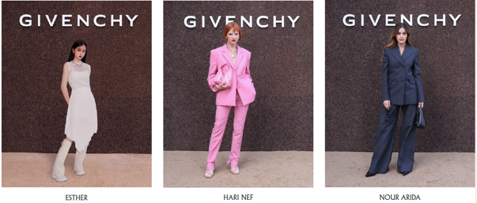
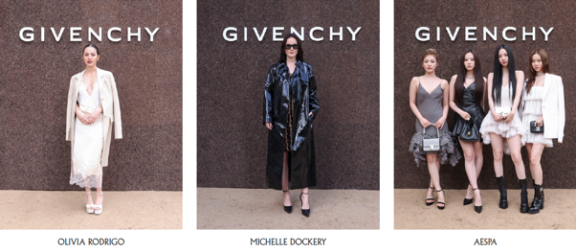
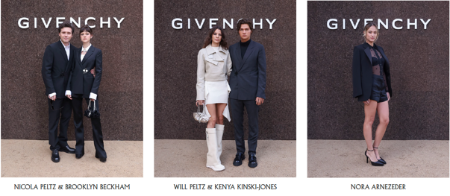
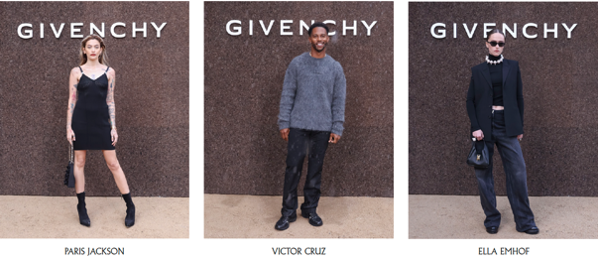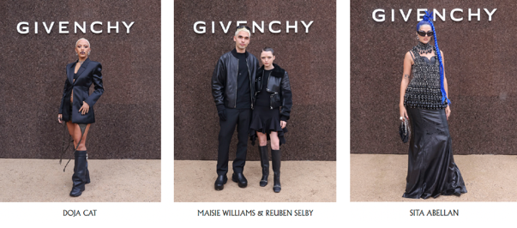
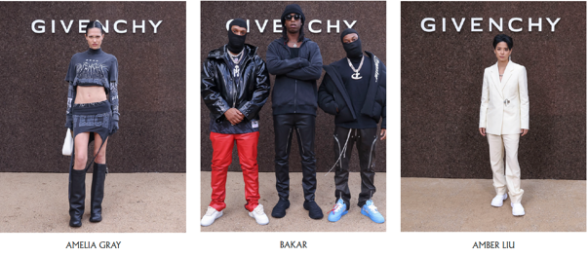

---
For press enquiries please contact:
The Qode – Shaheena Usman – shaheena@theqode.com
The Qode – Gopika Madan – gopika@theqode.com
The Qode – Evane Dsouza – evane@theqode.com

